# PG-ABM: An Agent-based Model of Politogenesis

## Abstract

Politogenesis concerns about how and why polities are originated. In this study we first discuss a formal theory of politogenesis, and then propose a model (an agent-based simulation) that helps exploring where and when the most primitive socially complex polities, i.e. chiefdoms, can emerge from simple non-complex societies.

## Introduction

### Motivation

The origins of the social life is no less a great wonder to social scientists than what the origins of the universe is to biological or physical scientists. Social complexity (polities) started emerging at several places at different times long after humans originated; but when, how and why at those particular times and places?

Besides the intrinsic wonder the politogenesis problem possess, we can list several significant benefits of studying this phenomenon. I will categorize these benefits under thee classes: i) past, ii) present, and iii) future. First, by increasing our understanding about earliest complex societies we could argue more robust theories on development of more complex societies. This is my description for the benefits of the past. Second, people being identified by the time they live in, it is no easier to comprehend contemporary sociopolitical complexity. Having a better understanding of the earliest complexity emergence we can detach ourselves and look from a broader perspective to the present. Last but not least, in order to come up with some possible insights for the future we first have to examine the past. We learn from the past, we test and verify theories again by the data of the past and also of the present and thus we try to predict the future.

### Simple and Complex Societies

At the beginning, humans used to be living in simple societies. Members of these simple, non-complex societies were socially unranked (i.e., egalitarian), they did not have any centralized managements, and their social relations were primarily based on kin-relations.

Complex societies differentiate from simple ones in several ways. The most prominent feature of socially complex societies is that, even in the simplest complex societies (i.e. chiefdoms) political and economic power is exercised by a single person (a chief) who is supported by a group of persons where each of these supporters rules their own local communities. Therefore, chiefdoms are socially ranked, have a specialized management, and the social relations are non-kinship based (Cioffi-Revilla 2014).

**Social Theories of Politogenesis**

### Narrative Theories

We first see the discussion on the origins of polities in the social contract theory of Rousseau (Rousseau 1762). He claimed that hunter-gatherer society were egalitarian and lacked social institutions for collective governance. This indeed came out to be true and proved with new empirical data attained by the excavations in 20th century. Some other supportive narrative and formal social theories of politogenesis have also been introduced since then.

According to contract theory, after the end of the latest glacial period natural bounties flourished in some places, therefore a “contract” emerged between social groups of haves and have-nots. Finally, by joining in civil society all sides enjoyed the rule of law against excessive oppression by the strongest or wealthiest.

Modern narratives explain how chiefdoms used to operate based on three strategies. First, chiefs had to have control over precious goods (material or spiritual); second strategy is tributary (in acknowledgment of subjugation), and the last one is redistribution (payoff in exchange of obedience). We see that the question of how chiefdoms emerge (*not operate*) is ignored in most of these studies.

### Formal Theories

In *Looking at History Through Mathematics* (Rashevsky 1968) for the first time Rashevsky attempted to use mathematical equations (this was a new method rather than a causal theory formation) to study the earliest village-based polities by formulizing relationships among several key quantities involved in politogenesis such as size of land holdings, population sizes, distances, areas, amounts of food produced and consumed, and agricultural yield.

Later, the Control Theory was introduced based on the theory of Political Coalitions in political science (Riker 1962). Control Theory is a game-theoretic theory where a chief provides side-payments (that he has full control over) to confederates in exchange for their loyalty. By doing so, confederates keep their loyalty while governing a regional territory. Thus, chiefdom runs over 2-3 levels of administrative hierarchy.

More recently, Cioffi proposed a canonical theory, which is built on earlier informal theories of socio-political complexity, probabilistic uncertainty and collective action. This theory explains politogenesis by two processes at different time scale (named as fast and slow processes).

Fast processes consist of situational changes (opportunities & threats) that are integrated over time. These integrations have various consequences such as memories of leadership, experiences, payoffs, and similar lessons from collective action; and finally lead to serious changes in sociopolitical complexity such as beliefs, norms, expectations, and social relations. Since the theory embraces uncertainty, politogenesis occurs as one of several possible emergent outcomes in the possibility-space of a society (Cioffi-Revilla 2014).

### Challenges

The challenges met while studying early politogenesis can be described in six folds. These challenges are identified by Cioffi in his work (Cioffi-Revilla 2014).

#### Conceptual Challenges

Not having a common vocabulary was the greatest challenge of scientists especially before the invention of printed press. Some scientists were describing and theorizing some concepts at some place of the world but the same vocabulary were being used in different meanings by others living in other geographies. These uncommon, therefore ambiguous and unclear vocabularies were leading to unnecessary debates among scientists.

More recently, communication problem of scientists have been diminished dramatically but the conceptual challenges still remain to exist in some fields of science including politogenesis. The solution to this is to apply systematic methods of concept formation to come up with universally accepted definitions of politogenesis related terms such as equality, chiefdom and state.

In our model we depend on concepts that are systematically defined, clarified and described in Cioffi’s work (Cioffi-Revilla 2014).

#### Formal Challenges

As an extension to the lacking universally accepted common concepts, there is also no such a mathematical formalism of politogenesis. Social scientists have adapted and prefer different formalism techniques for different social phenomena. For instance, decision models and game-theoretic models are common in the fields of bargaining and negotiations. Another nice example is the use of dynamic systems of differential equations in the fields of social dynamics (from demography to arms races).

#### Ontological Challenges

Politogenesis deals with social entities such as actors (individuals or households), situations, perceptions, decisions, behaviors and institutions. We capture and model these concepts as data members or methods (encapsulated in classes) in object oriented programming.

#### Empirical Challenges

One of the biggest challenges we had (and indeed we still have) is the lack of field data of sites for primary chiefdom formation. Although we have valuable information on early state sites such as Uruk, Yellow River Valley, that is not the case for the simplest social complexities.

#### Comparative Challenges

Politogenesis have occurred in several regions at different times. These emergences happened only a few times in the human history (naturally can never going to happen again and therefore cannot be replicated to experiment unless we grow artificial societies). Common ones as well as the individual features of these emergences can also be studied in terms of cross-cultural comparative research.

#### Computational Challenges

This study is primarily focused on this particular challenge. In the remaining of this paper I describe the computational challenges that I cope with and discuss my responses to those challenges. Finally, I propose an agent based computer simulation model based on the formal mathematical politogenesis theory of Cioffi (Cioffi-Revilla 2014).

In the next chapter I explain why I chose agent based modeling as my modeling approach rather than other computational modeling techniques such as system dynamics or microsimulation, which are common in modeling probabilistic models.

## Computational Modeling Techniques

The event-based causal structure of Cioffi’s theory captures the ontology of politogenesis in a way that is closer to agent simulation than the systems dynamics of differential equation-based systems. Although it is a mathematical theory based on probability theory, the social aspect of the problem with many interrelated dynamics and causal relations, occurrence and emergence of events makes the system more suitable for an agent-based model.

In system dynamics we describe a target system with its properties and dynamics by using a system of equations, and derive its future state from its current state. In a system dynamics model individuals (or other discrete entities such as products, events, etc.) are represented by their quantities so they lose any individual properties, histories or dynamics (System Dynamics — AnyLogic Simulation Software n.d.). Figure 1 is given as an example to the specific graphical description language of system dynamics models.

As stated by Gilbert and Troitzsch (2005) system dynamics is based upon differential equations and restricted to the macro level. Therefore, the properties of undifferentiated whole are represented by the states of stock/flow and changes in level/rate variables in these equations.

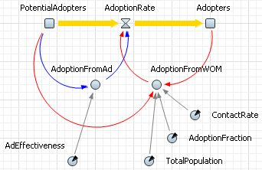

Figure System dynamics stock and flow diagram

Microsimulations were the initial solution to this problem by incorporating attributes of individual properties and their transition probabilities into the model. Therefore, unlike system dynamics models, microsimulation models are stochastic. Although microsimulation models have attributes of individuals, entities in the system do not interact with each other, which is indeed always the case in social/complex systems. Another disadvantage of microsimulations is that decisions of the entities are not based on some motivations or intensions, they rather act simply based on the probabilities predetermined for every period of time for the entire simulation; therefore, microsimulations are rather for predictions than providing any explanations of micro-level or emergent level dynamics of social systems.

On the other hand, as a much more natural way than describing stocks and flows, in agent-based modeling one can model individuals’ (i.e. agents’) attributes, motives (intensives), perceptions (senses), cognitive (decision making and learning) skills, actions, reactions and interactions in object oriented programming (OOP). This object oriented programming approach became popular in computer science in the early nineties and has allowed computational social scientist researchers create such models in a very easy and natural way. Unlike other modeling approaches based on equations where one has to define the phenomena precisely, ABMs are not meant to be precise, hence do not lack of flexibility in exploring phenomena.

Moreover, modeler can create an environment for the agents to dwell on and interact, spatial or abstract; where connections can be on neighborhood basis only, or at social network level. Then the modeler can run his model and observe the emergent behavior at a higher level. ABMs therefore can be extremely flexible as the modeler can freely decide what kind of constraints she would like to put on her model. Therefore, we model this theory using agent based simulation techniques and implement in MASON toolkit (Luke et al. 2003).

Additionally, ABMs are complete (and in this manner precise) because every perception, decision, and action of an agent (and its interactions with other agents and the environment) has to be decided precisely and implemented in the model. Another advantage of agent-based models in exploring social or complex phenomena is the extent of heterogeneity in the model. Every single individual in the model might have different set of features (as in the case of human societies).

## Cioffi’s Formal Theory

This study is primarily based on Cioffi’s formal theory of politogenesis. Cioffi in his article makes thought experiments and comes up with nine required features (components of potentials) that a simple society has to possess to become chiefdom (Cioffi-Revilla 2014). The basis of Cioffi’s theory can be summarized in two categories. The first one is the archaeological records that

* Homo sapiens sapiens originated 200 thousand years ago in Africa
* First chiefdom was formed 10 thousand years ago in Northern Mesopotamia

His second basis is potential accumulation and realization approach to politogenesis. Cioffi asks three core questions and theorize the politogenesis in a causal perspective by answering these questions:

* How the requirements are met (potential attained) for a simple society to start evolving into an initial social complexity?
* What are the characteristics of these requirements (elements of the potential)?
* Under what circumstances can the potential be realized (and hence the initial social complexity is emerged)?

### Definitions and Concepts

Cioffi identified nine required elements of potential. A polity cannot be emerged if any of these necessary conditions is missing:

* Kinship knowledge
* Communicative ability
* Normative sociality
* Social identification ability
* Environmental knowledge
* Knowledge of normal vs. rare events
* Food procurement ability
* Homicidal ability
* Collective action ability

Due to space limitations I won’t discuss each of the items listed above again as they are available in Cioffi’s paper (Cioffi-Revilla 2014). In his paper, he further defines some basic concepts such as polity, social complexity, chiefdom and politogenesis.

## Model Description

In this study we build a computer simulation model based on Cioffi’s formal mathematical theory (Cioffi-Revilla 2014). We build an agent-based model where simple societies can meet necessary conditions and hence accumulate potential. Finally if the potential is realized societies then emerge into socially complex chiefdoms (Depicted in Figure 2).

Figure 2 Forward sequential causal logic tree for initial politogenesis grafted with a first-order backward conditional causal tree for complexity potential (conditions 1-9). Added Opportunity (O)and Willingness (W) notations [Adapted from Cioffi (2014)]



The environment consists of a biophysical landscape initially inhabited by a kin-based society. The initial agent rules are based exclusively on knowledge and skills such as those specified by conditions 1–9. Situational changes activate agent decision-making and produce decisions, behaviors, and emergent patterns that generate politogenesis.

As suggested by Cioffi, I employ his theory to predict precise locations for politogenesis, based on prior causal potentials. If this was a worldwide model then we would expect the locations with highest potentials should coincide with the four politogenic regions known from archaeology (the Levant, China, Peru, Mesoamerica) as well as related areas that may not have generated states until relatively recent times but did generate chiefdoms (e.g., North America, Amazonia, subsaharan Africa, south Asia, and Europe). However since I only work on Eurasia I am expecting the polities to emerge at south Asia and Northern Mesopotamia (from the Levant to the south west of Caspian Sea).

## Model Outline

Human evolution such as attainment of ability to speak as well as the natural history such as the end of glacial period play the most important roles on the emergence of social complexities.

Agents (Societies) are initially assigned to random places on the map and based on the living conditions they are able to settle down or move (or die). At every step every agent checks if the society possesses all of the nine qualities (necessary conditions). If all of the attributes are possessed, and if there is enough willingness and opportunity, then the potential is realized and a simple society evolves into a complex one. This model flow and design is shown in Figure 3.

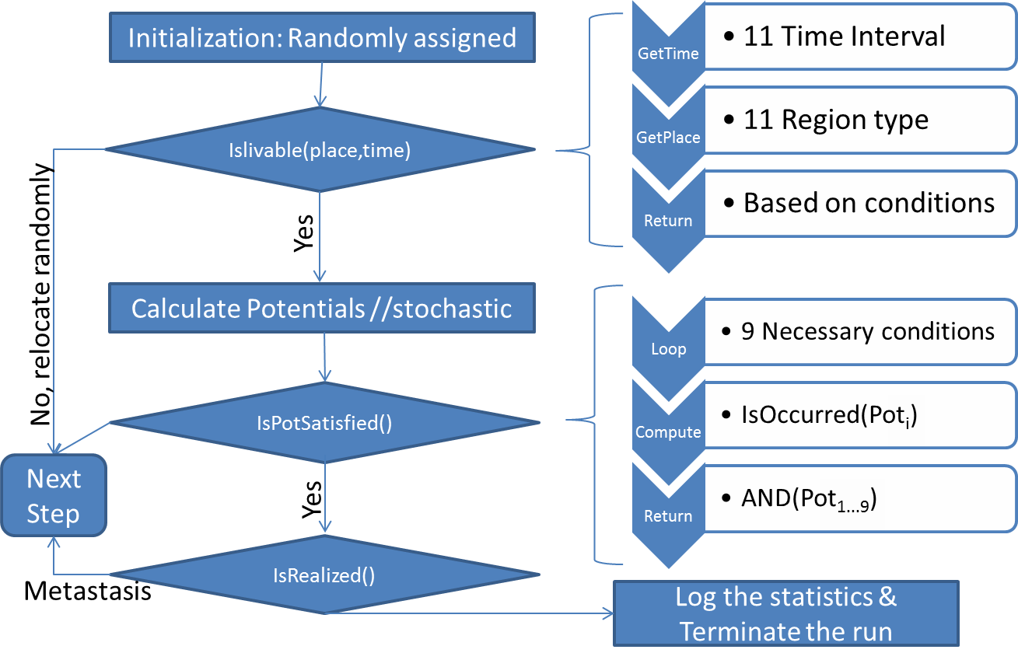

Figure Model Design

### Biophysical History of Eurasia since the Last Glacial Maximum

In order to understand why social complexities first emerged around 10,000 BC we first have to identify the conditions before that. Therefore in this section we look at the biophysical history of Eurasia during the last 150,000 years (Adams n.d.):

* Warmest phase of the Eemian interglacial, ~ 130,000 - 120,000 y.a.
  + The plant fossil record suggests conditions warmer and moister than present
* Heinrich events across Eurasia, about 110,000 - 70,000 y.a
  + Sudden cold and arid events extending across Eurasia
* 70,000-55,000 14C y.a. Stage 4 Glacial Maximum
  + This cold stage resembled the Last Glacial Maximum/Stage 2
* 55,000-30,000 14C y.a.
  + Cooler but fairly moist conditions
* 30,000-25,000 14C y.a
  + Conditions became still drier (with dry winters) and cooler
* LGM and late Glacial 18,000-14,000 14C y.a
  + Conditions all across northern Eurasia appear to have been dry and treeless, dominated by polar desert or semi-desertic steppe-tundra
* 12,000-11,000 14C y.a.
  + An initial moistening and warming of climate across Eurasia
* Eurasia (color map) 11,000 14C ya just before Younger Dryas
  + The map that I use in my model belongs to this era
* Younger Dryas 11,200-10,200 14C y.a.
  + Strong cooling and aridity
* Early Holocene - 9,000 14C years ago
  + A sudden warming and moistening of climate starting around 10,000 14C y.a
* 8,000-7,000 14C y.a
  + Conditions remained considerably warmer and moister than at present, with much greater vegetation cover in desert regions
* 6,000-5,000 14C y.a
  + Forest vegetation exceeding its present limits in most parts of Eurasia

PG-ABM is a spatially explicit model. Societies live in Eurasia (Figure 3), and at some point they emerge into polities. In this section we discuss how societies (agents) respond to these changes and finally evolve into complex systems is discussed in the next section.

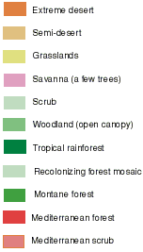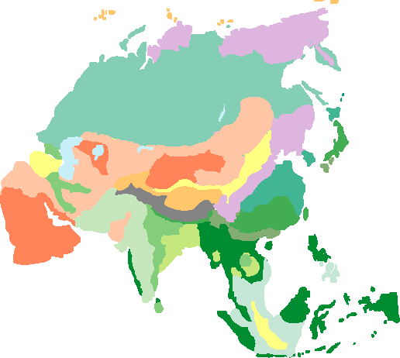

Figure 4 Eurasia ~9,000 BC. Adapted from Preliminary land ecosystem maps of the world since the Last Glacial Maximum Compiled by Jonathan Adams, Environmental Sciences Division, Oak Ridge National Lab

### Agents

Agents in our simulation represent simple societies, which may evolve into more complex societies by attaining required conditions and realizing their potentials.

## Programming Details

PG-ABM model is implemented in Java using MASON toolkit (Luke et al. 2003). The key property of this model is using the color map of Eurasia 11,000 14C ya and extracting useful information out of it. Program reads in the colors of the map and gets the useful biophysical information described in the legend using the following code block:

## Discussion of Results and Conclusion

Image i = new ImageIcon("eurasia.png").getImage();

BufferedImage b = display.getGraphicsConfiguration().createCompatibleImage(i.getWidth(null), i.getHeight(null));

Graphics g = b.getGraphics();

g.drawImage(i,0,0,i.getWidth(null),i.getHeight(null),null);

g.dispose();

display.setBackdrop(new TexturePaint(b, new Rectangle(0,0,i.getWidth(null),i.getHeight(null))));

Bag agents = pg.world.getAllObjects();

for (Object a : agents) {

// get the land color

Int2D loc = pg.world.getObjectLocation((Agent) a);

int c = b.getRGB(loc.x*PG.SPARSE_RATE, loc.y*PG.SPARSE_RATE);

int re = (c & 0x00ff0000) >> 16;

int gr = (c & 0x0000ff00) >> 8;

int bl = c & 0x000000ff;

Color landColor = new Color(re,gr,bl);

…

}

Below are the output images of ten different runs of our model. Blue dots represent the complex societies emerged at early Holocene period. The reason for emerging at this period is indeed given in the *Biophysical History of Eurasia since the Last Glacial Maximum* section. After the sudden warming and moistening of climate around 10,000 14C years ago, we observe a plentiful amount of natural resources in Eurasia which finally leads to the realization of potentials. Although there was another warm season around 130,000 - 120,000 y.a. the potential was still not fully satisfied because at least one of the necessary conditions, the communicative ability was missing (which is also a necessity for coordinating collective action).

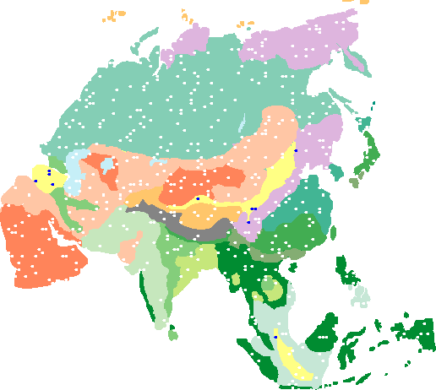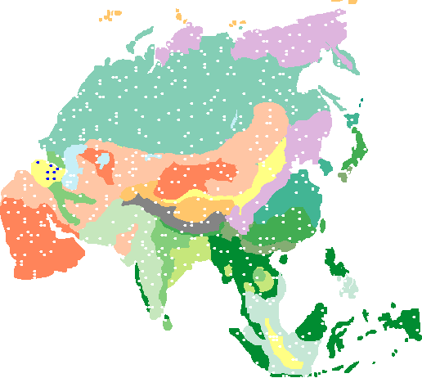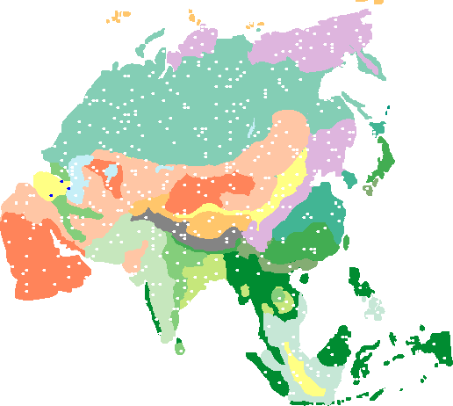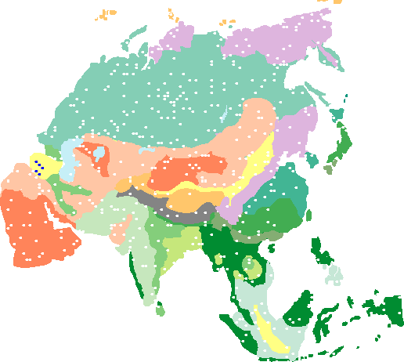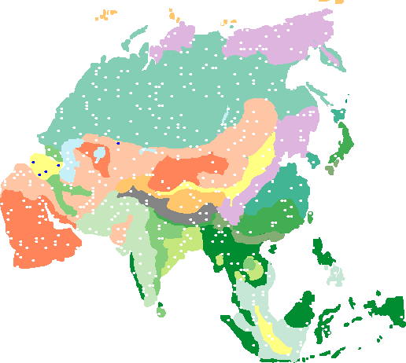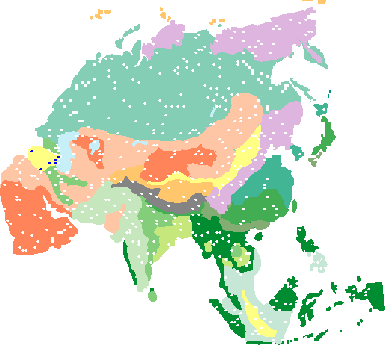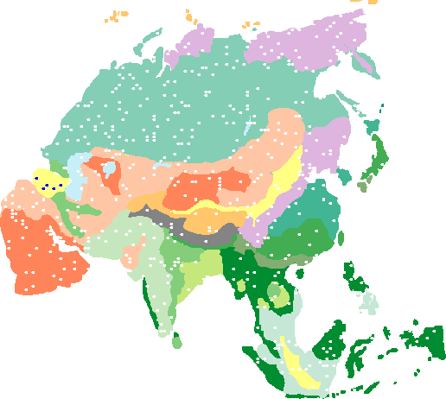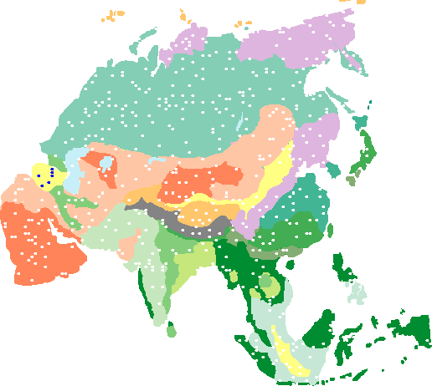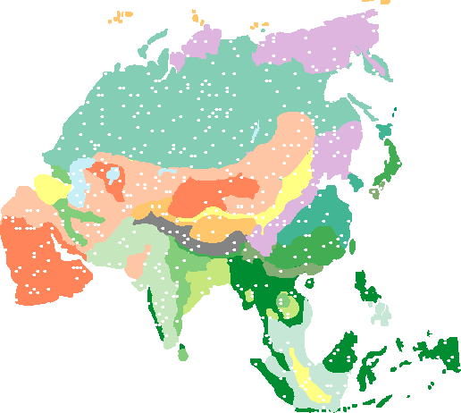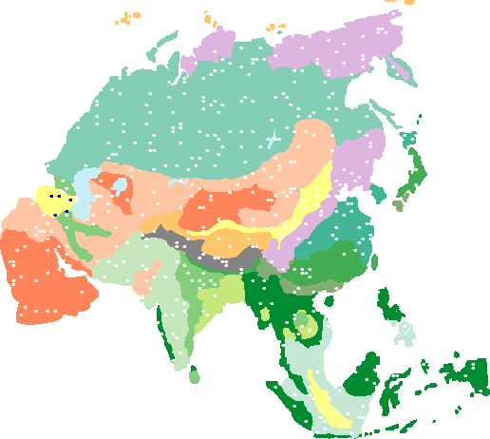

## References

Adams, Jonathan  
 N.d. Atlas Of Palaeovegetation In Eurasia During The Last 150,000 Years. Environmental Sciences Division, Oak Ridge National Laboratory, Oak Ridge, TN 37831, USA. Atlas Of Palaeovegetation In Eurasia During The Last 150,000 Years. http://www.esd.ornl.gov/projects/qen/nercEURASIA.html, accessed December 17, 2014.

Cioffi-Revilla, Claudio  
 2014 A Formal Theory of Politogenesis: Towards an Agent Simulation of Social Complexity Origins. SSRN Scholarly Paper, ID 2429322. Rochester, NY: Social Science Research Network. http://papers.ssrn.com/abstract=2429322, accessed November 6, 2014.

Gilbert, Nigel, and Klaus Troitzsch  
 2005 Simulation for the Social Scientist. 2 edition. Maidenhead, England ; New York, NY: Open University Press.

Luke, Sean, Gabriel Catalin Balan, Liviu Panait, Claudio Cioffi-Revilla, and Sean Paus  
 2003 MASON: A Java Multi-Agent Simulation Library. *In* .

Rashevsky, Nicolas  
 1968 Looking at History through Mathematics. M.I.T. Press.

Riker, William H  
 1962 The Theory of Political Coalitions, vol.578. Yale University Press New Haven.

Rousseau, Jean-Jacques  
 1762 Du Contrat Social Ou Principes de Droit Politique. Oeuvres Complètes 3.

System Dynamics — AnyLogic Simulation Software  
 N.d. http://www.anylogic.com/system-dynamics/, accessed October 14, 2014.